***DOCUMENTATION OF MY PROJECT***

* **Project Overview:**

The primary goal of my project is to showcase the ecommerce website which is based on shopping of Samsung smart phones. Apart from showcasing smart phones my website also provides basic phone specifications for the user which enhances user experience.

* **Scope and Objectives:**

The scope and objectives of my project is to enhance the user experience and make an interaction with the website and the customer which showcases my project.

* **Design:**

The design is made while keeping in mind of the user and product which enhances my project. The design is simply minimal by making sure that the user feels engaged and comfortable when user comes to the website.

* **Stakeholders:**

The primary stakeholders of the website are the users or the buyers which purchase the product form the website or those which use our product.

* **User Interface (UI):**

The user interface of website should be minimal and while keeping this in mind my smart phone ecommerce website is minimal, user interactive and access-able.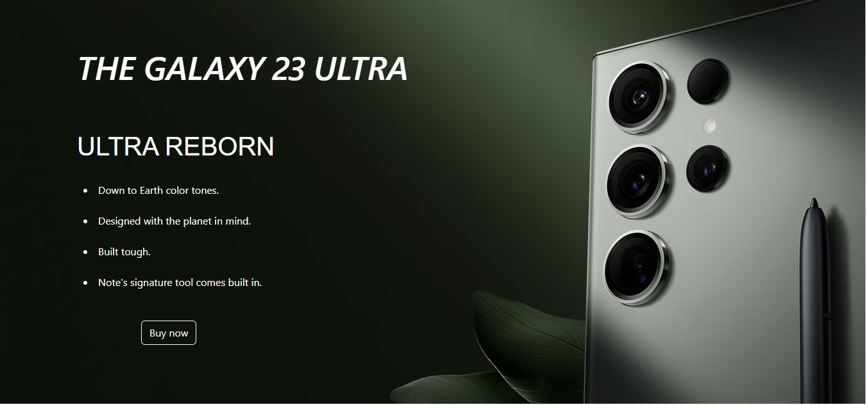

* **Project timeline:**

This particular website was made in keeping in mind of the product and the market scenario. So this website was made in 1 week which includes planning, designing and ecommerce integration.

* **Architecture:**

Architecture includes responsiveness and stability of the website on all platforms which includes mobile, tablets and pc’s with ecommerce integration.

* **Requirements:**

The requirement of the website includes Html, CSS, Java script and bootstrap. Html, CSS and bootstrap is used for the front end and java script is used for making the add to cart functionality in the website.



* **Deployment:**

The deployment phase of the website includes the process of making the developed website available and accessible for the users.

* **Lessons learned:**

The lesson learned from this project is to make sure that the website is developed while keeping in mind of the user. When user comes to the website he feels welcome by the discounts and user friendly experience which plays an important role in the development of the website.

* **Conclusion:**

The conclusion in the end my project involve great planning, seamless execution, and continual adaptation to meet evolving user needs and technological advancements.